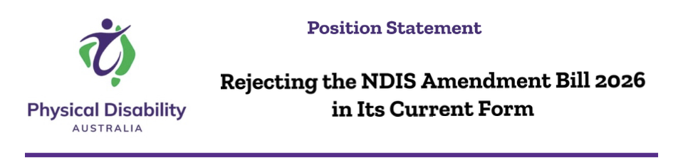

Our Statement
Physical Disability Australia (PDA) opposes the National Disability Insurance Scheme Amendment (Securing the NDIS for Future Generations) Bill 2026 in its current form and urges the Parliament not to pass it without substantial amendment. In PDA’s view, the Bill would narrow access to the NDIS, increase procedural burdens, weaken review rights, and create greater uncertainty for essential supports such as assistive technology, home modifications, and attendant care. These changes risk disproportionately excluding people with physical disability, particularly those with complex, lifelong, or degenerative conditions, and may be inconsistent with Australia’s obligations under domestic anti-discrimination law and the Convention on the Rights of Persons with Disabilities. PDA therefore calls for the Bill to be substantially redrafted, or withdrawn pending genuine, accessible, and properly resourced co-design with people with physical disability and their representative organisations.

Why This Matters
The NDIS was created to ensure Australians with disability have dignity, autonomy, and access to the supports required to participate fully in community life. For people with physical disability, that means wheelchairs, home modifications, personal care, pressure care, continence supports, and assistive technology. These are not optional extras; they are essential supports that underpin safety, health, survival, and independence.
In substance, the Bill shifts the NDIS away from its rights-based foundation and towards a more restrictive administrative model. It tightens access, narrows the practical scope of what may be considered “reasonable and necessary,” increases procedural burdens on participants, and risks destabilising essential markets for assistive technology and home modifications.
A scheme is not secured by excluding the people it was established to support.

Key Concerns
1. The Bill entrenches systemic exclusion People with physical disability are already underrepresented in the NDIS relative to their prevalence in the wider Australian community. The proposed functional assessments, “primary condition” requirements, and stricter permanence tests risk compounding that exclusion by screening out people with complex, fluctuating, or multi-system conditions that do not fit narrow administrative categories.
2. “Neutral” assessments may produce discriminatory outcomes Standardised functional assessment tools may place disproportionate emphasis on cognitive and behavioural domains while undervaluing mobility, dexterity, chronic pain, fatigue, and continence. Where environmental barriers are not properly accounted for, physical disability is reduced to a clinical deficit rather than understood in its full social and functional context. That creates a material risk of indirect discrimination, inconsistent with both the Disability Discrimination Act 1992 (Cth) and Australia’s obligations under the Convention on the Rights of Persons with Disabilities.

3. Reassessment and renewal impose a disproportionate burden Physical disability is often lifelong, stable, or degenerative. Forcing people with spinal cord injury, multiple sclerosis, motor neurone disease, or muscular dystrophy through repeated reviews squanders public resources, undermines health outcomes, and treats permanence as though it were doubtful rather than medically established.
4. Funding certainty is undermined for high-cost, essential supports Custom wheelchairs, hoists, and home modifications require long-term planning, specialist suppliers, and reliable funding pathways. Changes to plan suspension, support determinations, and claims integrity may introduce uncertainty into already fragile markets, particularly in regional and thin markets. Where funding certainty is eroded, safety is compromised and the risk of avoidable hospitalisation, institutionalisation, or unmet need increases.
5. Human rights must not be subordinated to administrative convenience The Bill weakens review rights, expands coercive information-gathering powers, and permits exclusion where another service system is said to exist. Taken together, these measures shift power further away from participants and towards the Agency. Administrative efficiency is not, of itself, a lawful or sufficient basis for diminishing rights, reducing safeguards, or limiting access to essential supports.
6. Consultation was tokenistic, not transformative Reform of this scale must be co-designed from the outset with people with physical disability. Instead, the core policy architecture appears to have been settled before meaningful community engagement occurred. Consultation is not a courtesy extended after decisions are made; it is an essential condition of lawful, effective, and credible reform.

Our Recommendations
Withdraw or substantially redraft the Bill through genuine, accessible, and properly resourced co-design with people with physical disability and their representative organisations before any further passage through the Parliament.
Remove or redraft the “functional capacity” and “all appropriate treatment” provisions so they do not exclude people with complex, lifelong physical impairments from the Scheme.
Exempt participants with recognised degenerative or stable physical conditions from routine reassessment and plan renewal burdens.
Guarantee funding certainty for assistive technology, home modifications, and attendant care, with explicit safeguards for thin and regional markets.
Restore and strengthen review rights, administrative accountability, and the central role of lived experience in determining what is “reasonable and necessary.”
Uphold Australia’s obligations under the CRPD and ensure that any measures aimed at sustainability are proportionate, rights-based, and non-discriminatory.

Closing
Sustainability and rights are not competing propositions. An NDIS that excludes people with physical disability cannot credibly be described as sustainable reform.

PDA remains ready to work constructively with Government and the Parliament on genuine reform. However, we cannot support legislation that elevates administrative control above the safety, dignity, independence, and equal participation of people with physical disability.
This Position Statement accompanies the detailed submission by Physical Disability Australia to the Parliamentary inquiry into the National Disability Insurance Scheme Amendment (Securing the NDIS for Future Generations) Bill 2026. - Submission: National Disability Insurance Scheme Amendment (Securing the NDIS for Future Generations) Bill 2026

Physical Disability Australia
Australia’s national peak Disabled People’s Organisation representing people with physical disability.




